Phase I and Phase II Results

IDAHO (ID)
A. Plots of Predictors vs. HPI (non-simple return)

Original HPI Series
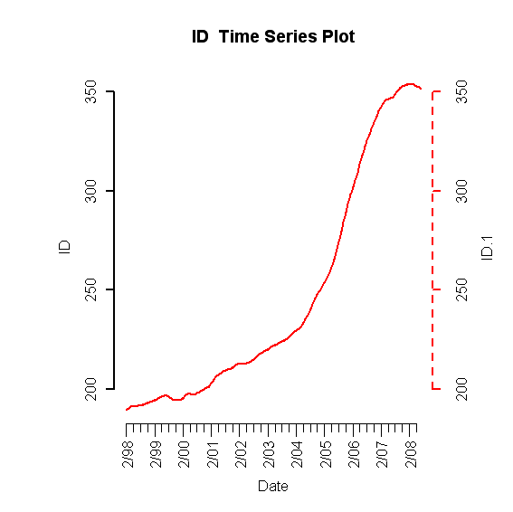
Building Permits
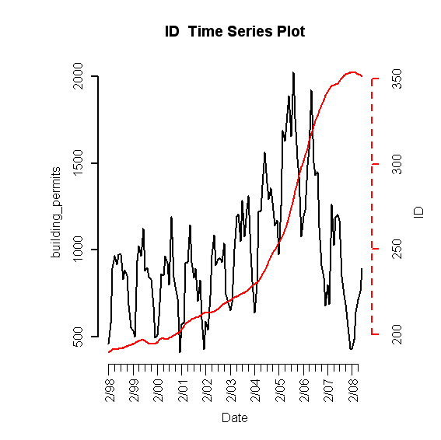
Foreclosures
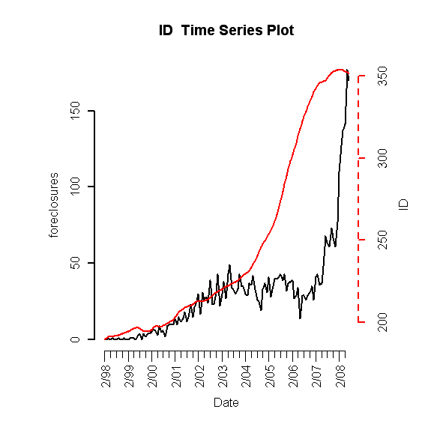

Population Size
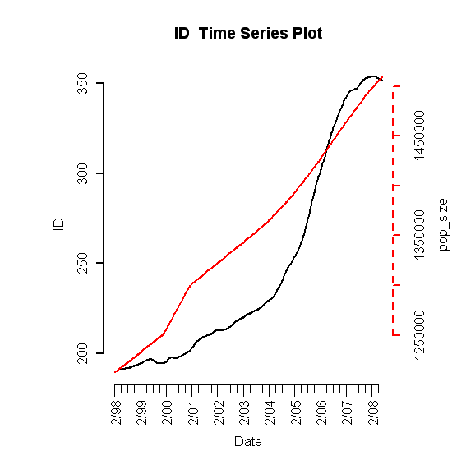
Unemployment Rate
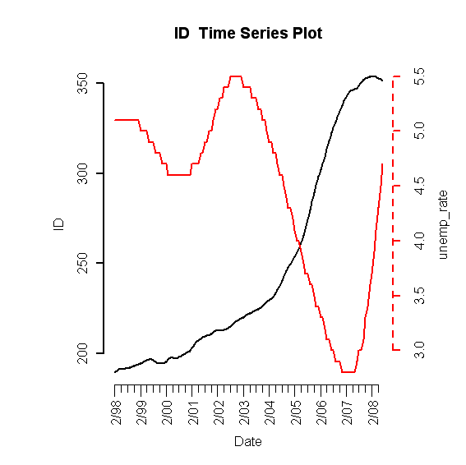
Mortgage Originations
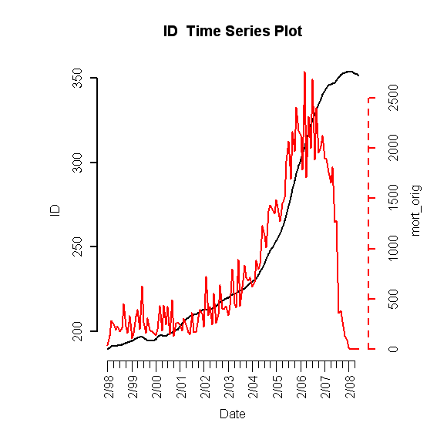

30-Year Commitment Rate
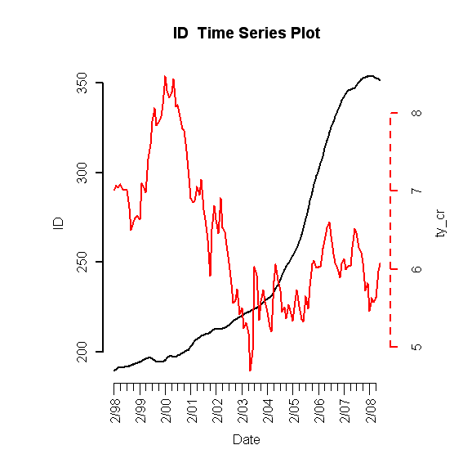
Median Income
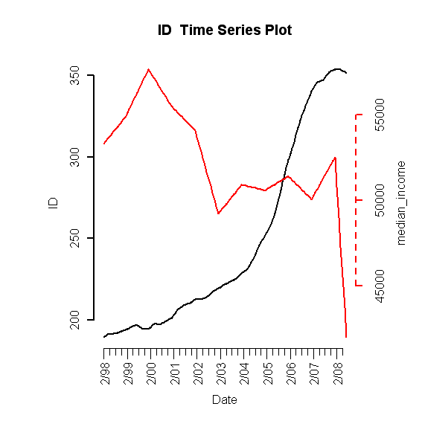
B. Scatterplots (simple return)

HPI vs. HPI
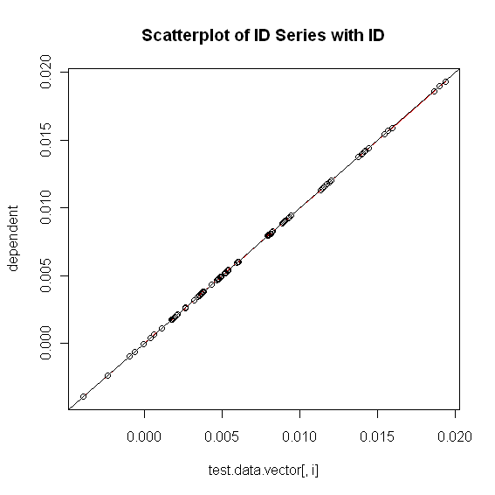

HPI vs. Building Permits
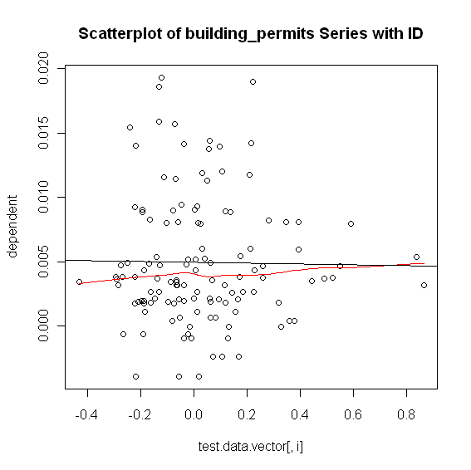
HPI vs. Foreclosures
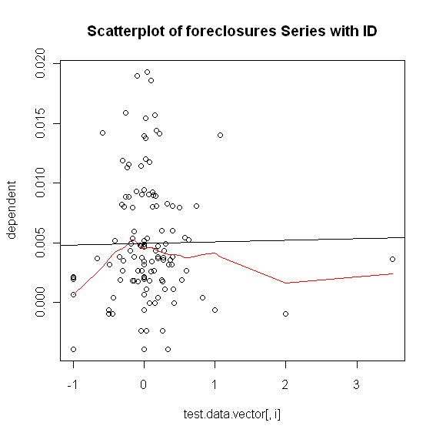
HPI vs. Population Size
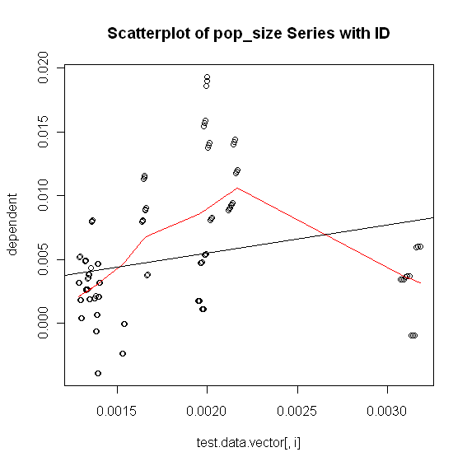

HPI vs. Unemployment Rate
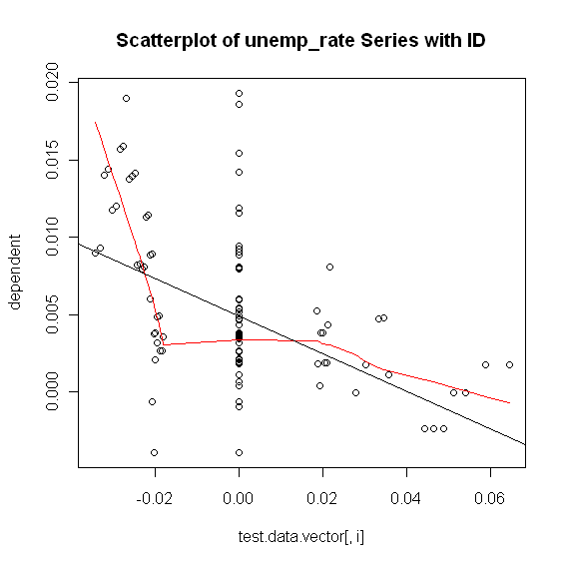
HPI vs. Mortgage Originations
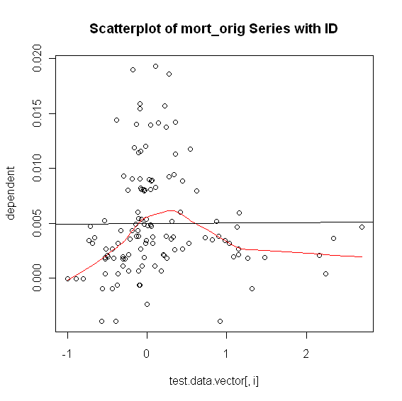
HPI vs. 30-Year Commitment Rate
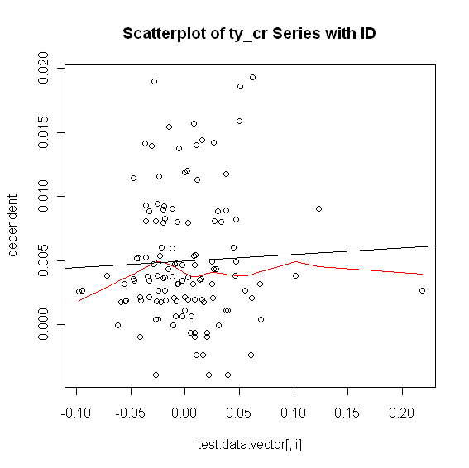

HPI vs. Median Income
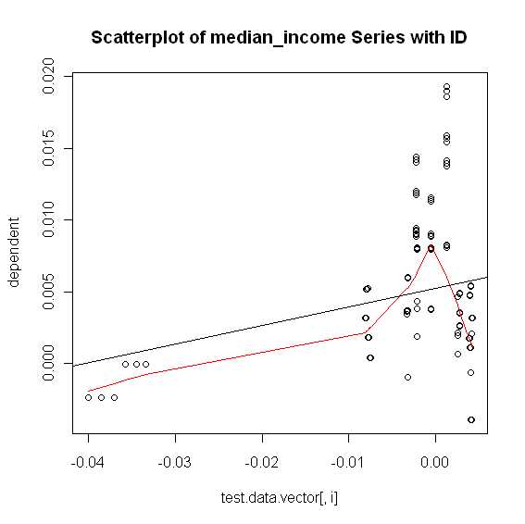
C. Exhaustive Stepwise Regression
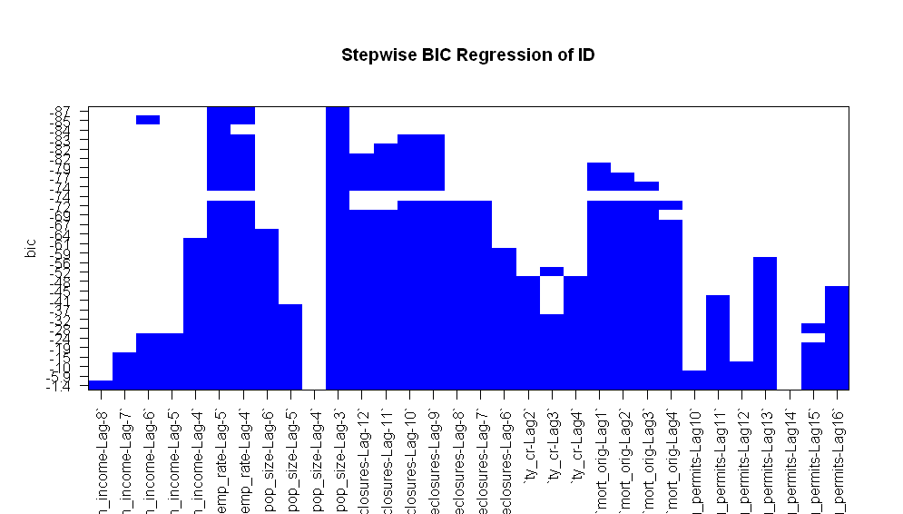

D. Final RLM Model
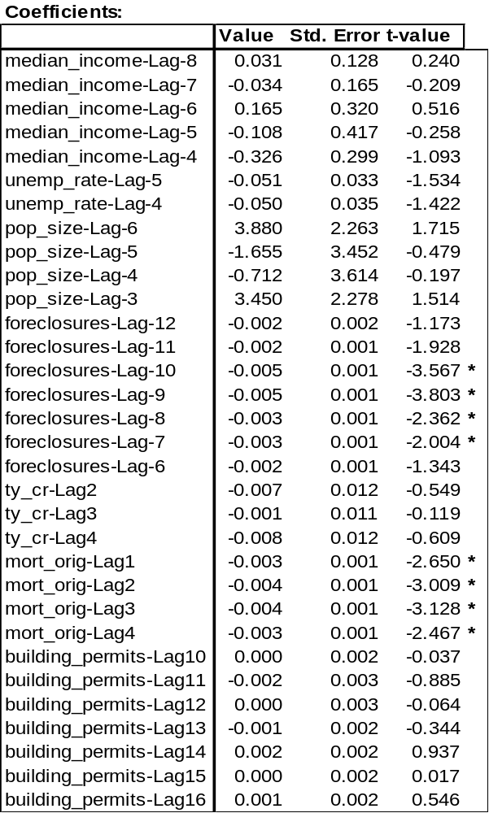

1. Phase I

ACF of Residuals
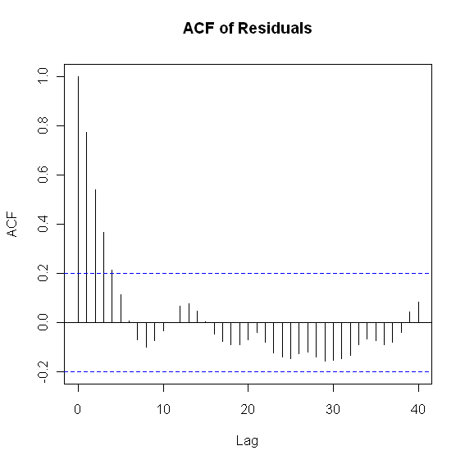
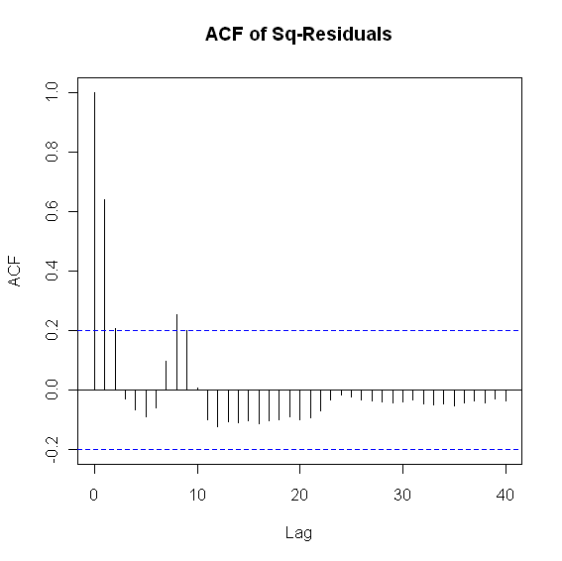
PACF and ADF Test

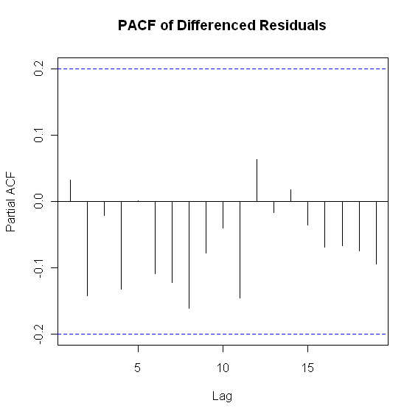
> adf.test(y$residuals, k = 3)
Augmented Dickey-Fuller Test
data: y$residuals
Dickey-Fuller = -3.6903, Lag order = 3, p-value = 0.02902
alternative hypothesis: stationary

2. Phase II

ARIMA(1,0,0) with zero mean
Call: arima(x = resid.data, order = c(1, 0, 0), include.mean = FALSE)

Coefficients:
ar1
0.7702
s.e. 0.0629
sigma^2 estimated as 6.112e-06: log likelihood = 444.17
AIC = -884.33 AICc = -884.2 BIC = -879.18

Box-Ljung Test
> Box.Ljung.test(arima.fit$resid,lag = 12, adj.DF = 12-params)
Q(12) P-value df
7.384673 0.7671 11

> Box.Ljung.test(arima.fit$resid^2,lag = 12, adj.DF = 12)
Q(12) P-value df
25.26165 0.0136 12

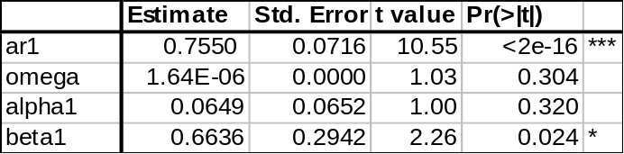

ACF of Residuals
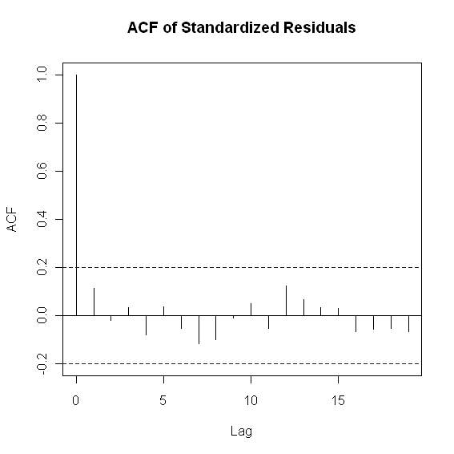
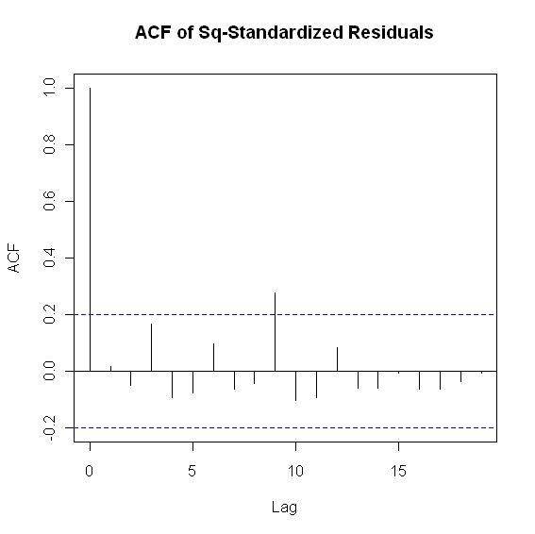

Box-Ljung Test

> Box.Ljung.test(sresi, lag = 12, adj.DF = 12-meanParams)
Q(12) P-value df
7.3162 0.7729 11
> Box.Ljung.test(sresi^2, lag = 12, adj.DF = 12-volParams )
Q(12) P-value df
17.41181 0.0657 10

CALIFORNIA (CA)
A. Plots of Predictors vs. HPI (non-simple return)

Original HPI Series

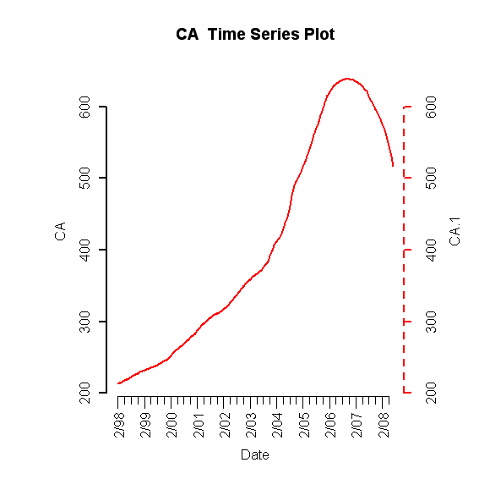
Building Permits
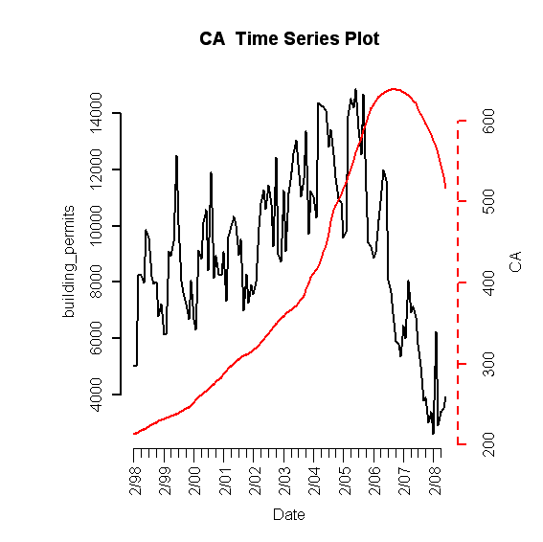
Foreclosures
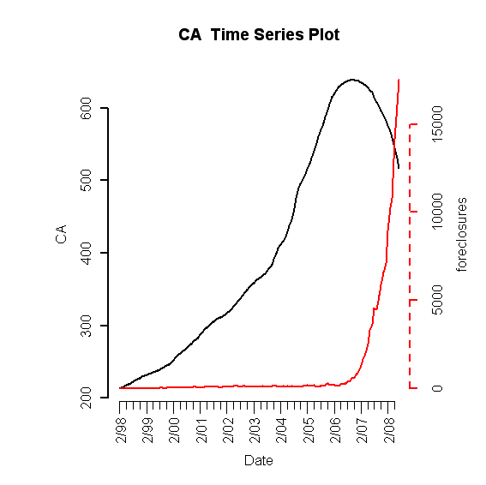

Population Size
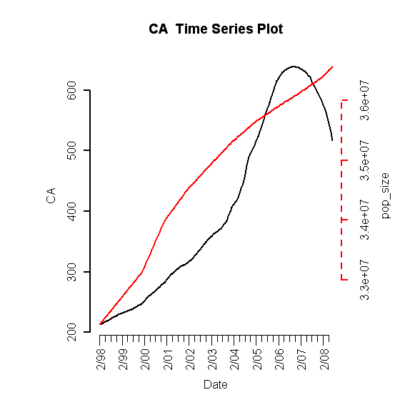
Unemployment Rate
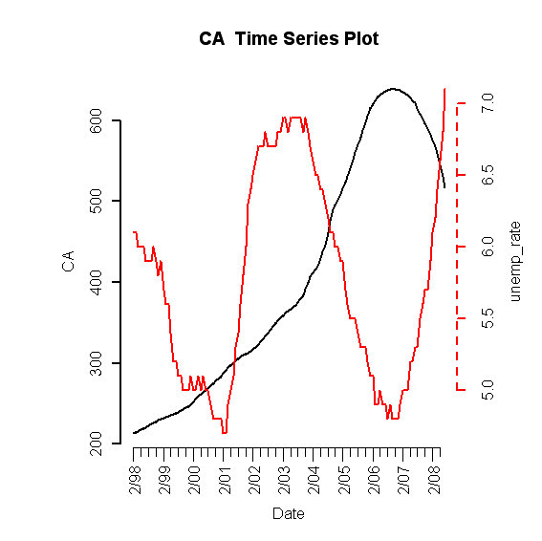
Mortgage Originations
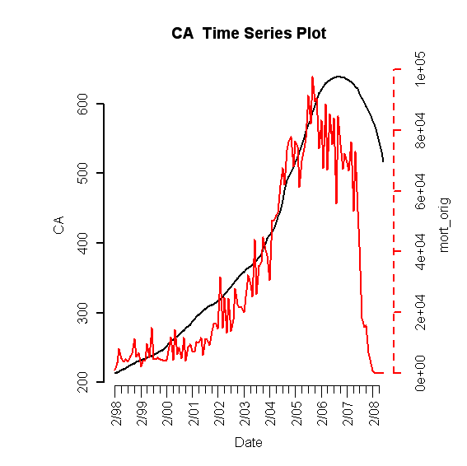

30-Year Commitment Rate
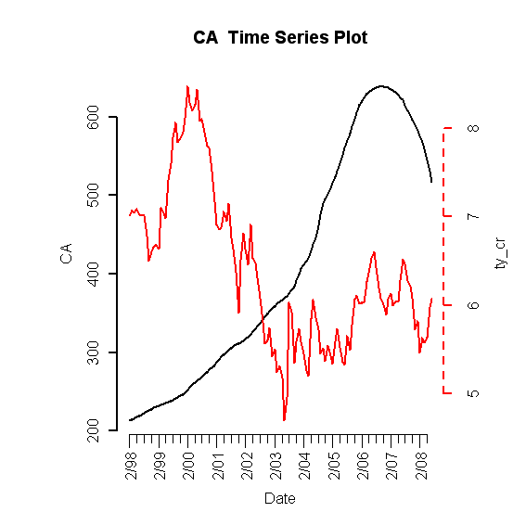
Median Income
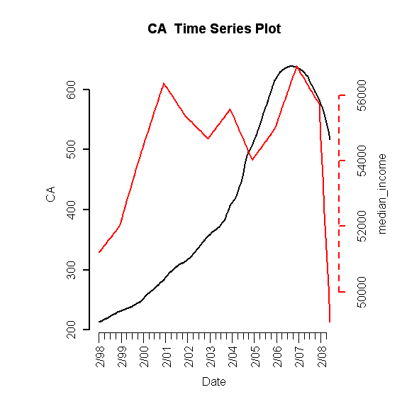

B. Scatterplots (simple return)

HPI vs. HPI
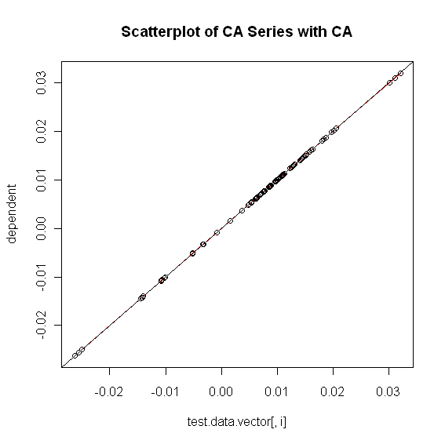

HPI vs. Building Permits
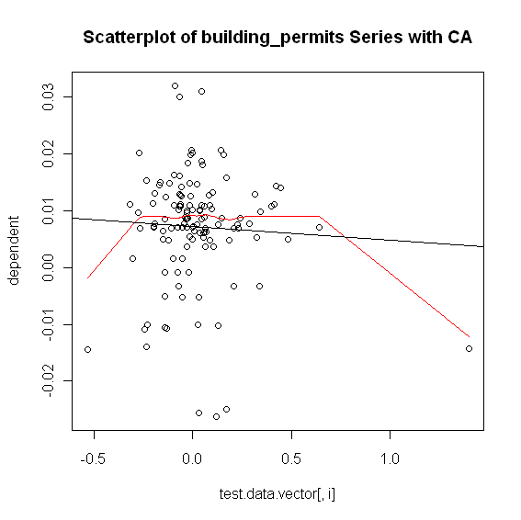

HPI vs. Foreclosures
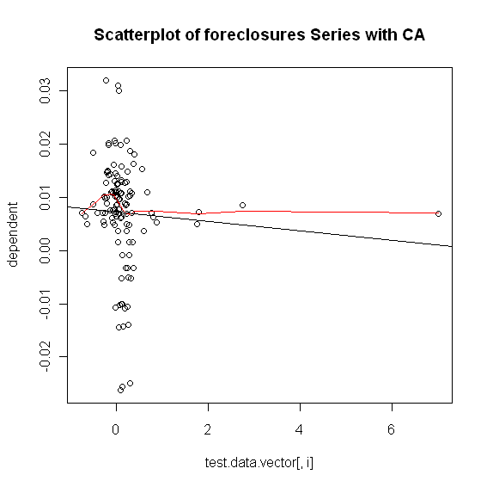
HPI vs. Population Size
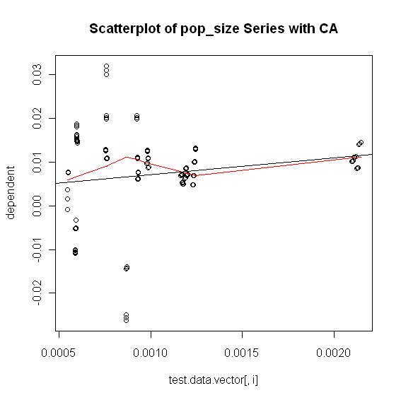

HPI vs. Unemployment Rate
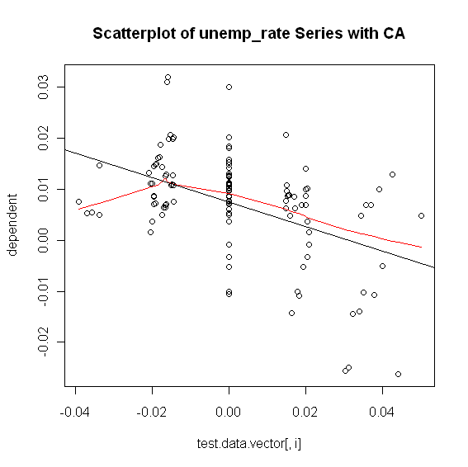
HPI vs. Mortgage Originations
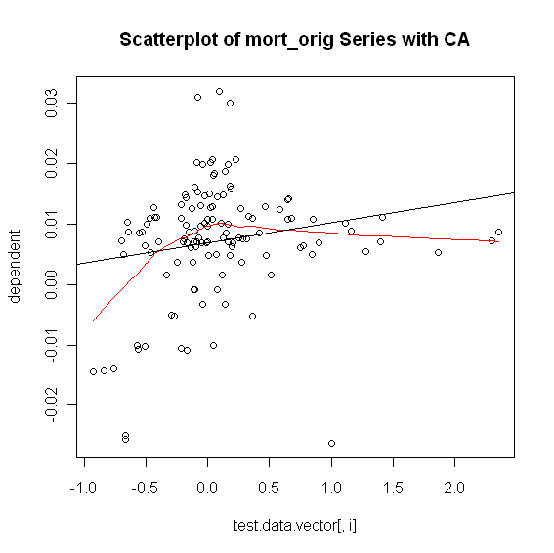
HPI vs. 30-Year Commitment Rate
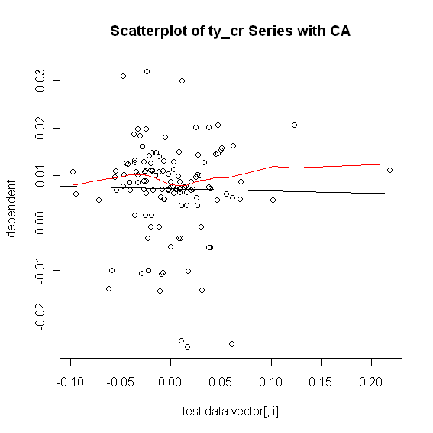

HPI vs. Median Income
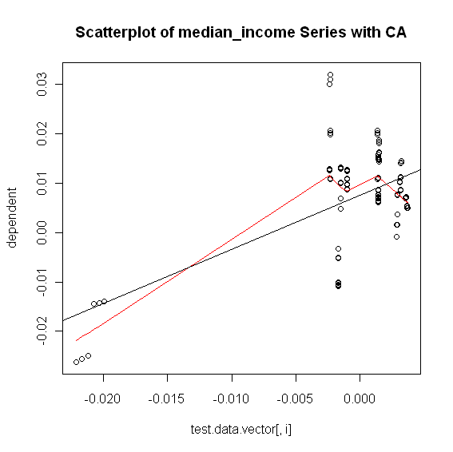

C. Exhaustive Stepwise Regression
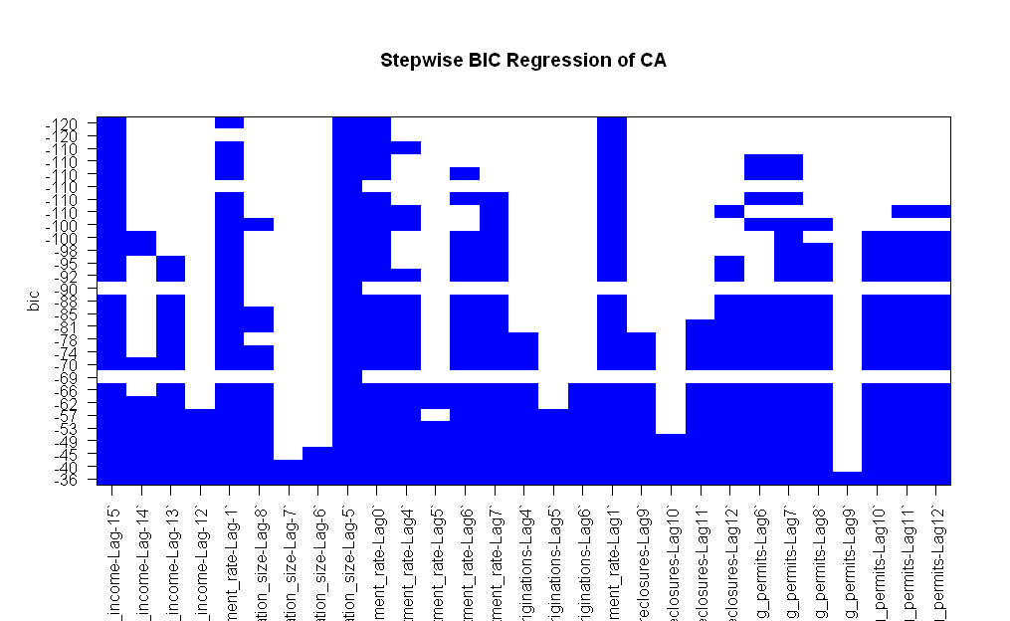

E. Final RLM Model
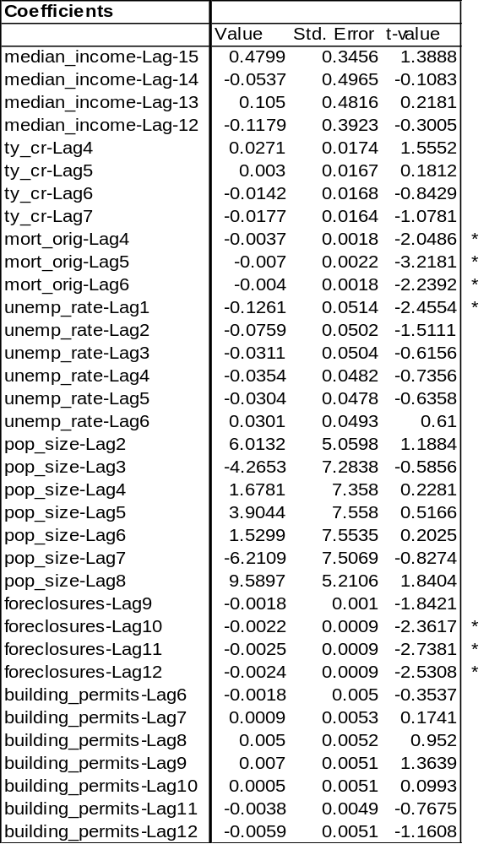

1. Phase 1

ACF of Residuals
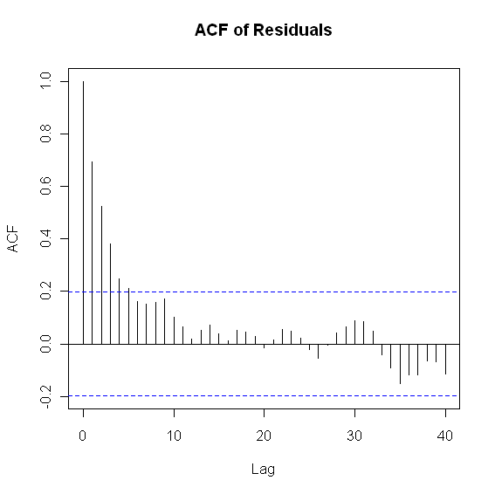
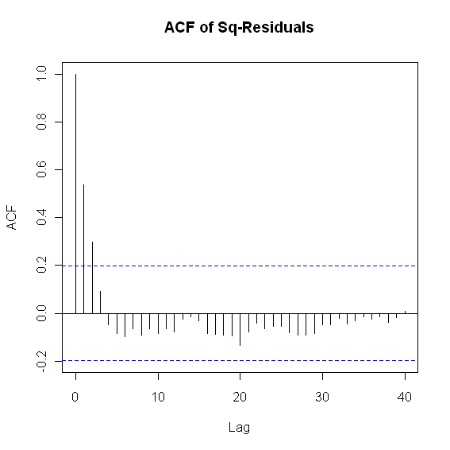
PACF and ADF Test

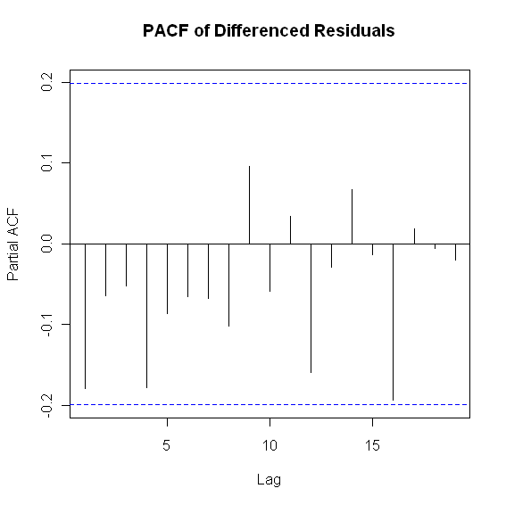
> adf.test(y$residuals, k = 2)
Augmented Dickey-Fuller Test
data: y$residuals
Dickey-Fuller = -3.5496, Lag order = 2, p-value = 0.04141
alternative hypothesis: stationary alternative hypothesis: stationary
Box-Ljung Test

> Box.test(y$residuals, lag = 12, type = c("Ljung-Box"))
Box-Ljung test
X-squared = 115.341, df = 12, p-value < 2.2e-16

2. Phase II

ARIMA(1,0,0) with zero mean
Call: auto.arima(x = resid.data, stationary = TRUE)

Coefficients:
ar1
0.7238
s.e. 0.0710
sigma^2 estimated as 1.539e-05: log likelihood = 403.57
AIC = -803.14 AICc = -803.02 BIC = -797.97

Box-Ljung Test

> Box.Ljung.test(arima.fit$resid,lag = 12, adj.DF = 12-params)
Box-Ljung test
X-squared = 6.2959, df = 11, p-value = 0.8529

> Box.Ljung.test(arima.fit$resid^2,lag = 12, adj.DF = 12)
Box-Ljung test
X-squared = 17.9114, df = 12, p-value = 0.1184

FLORIDA (CA)
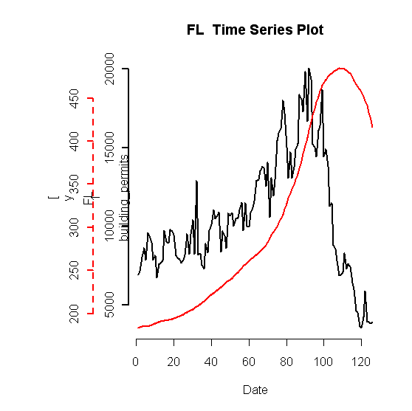
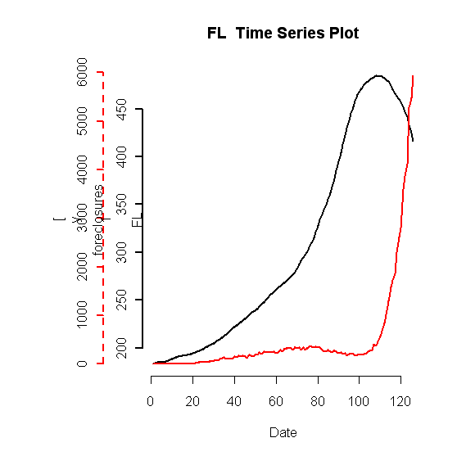
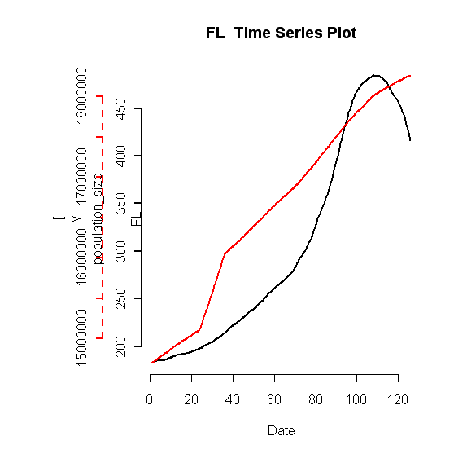

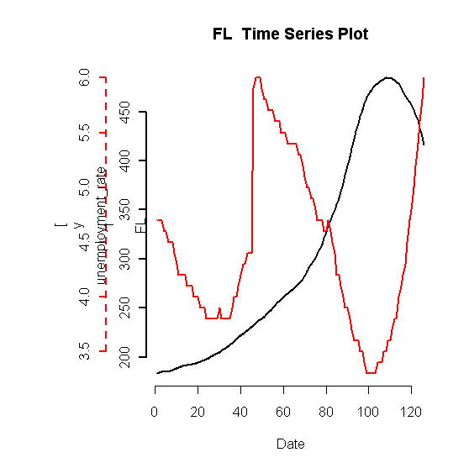
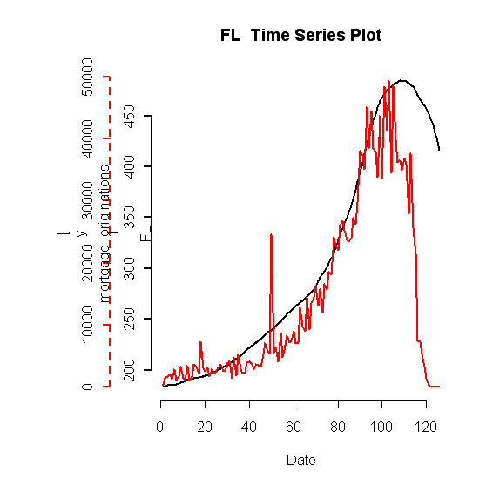
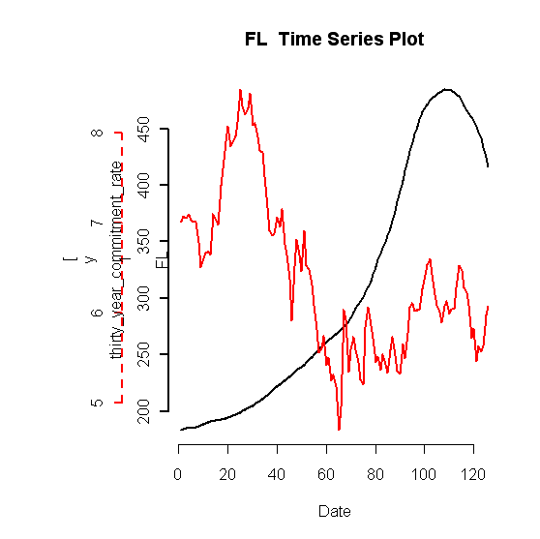
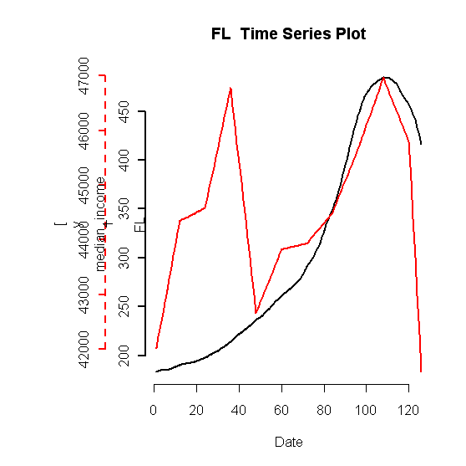
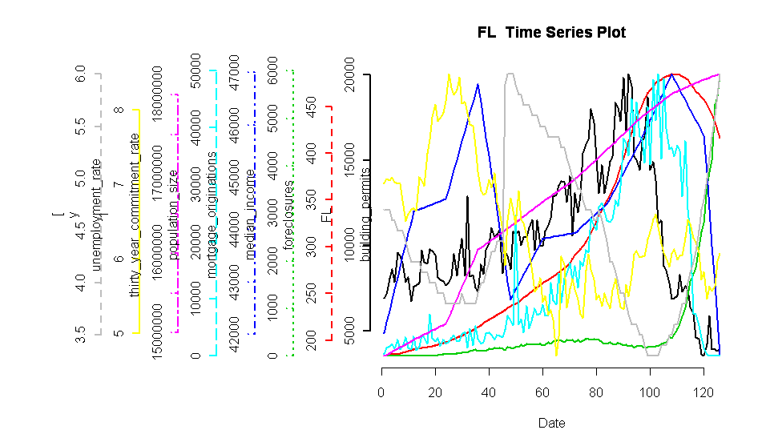

Based on these time series of the data, we picked the following lags to test:

Predictor Variable | Lag(s)
Median income | 0
30yr commitment rate | 0
Mortgage originations | 0
Unemployment rate | -4, -3, 1, 3
Population size | -6, 3
Foreclosures | -3,-1
Building permits | 0

Plots of lagged predictor variables and FL HPI:
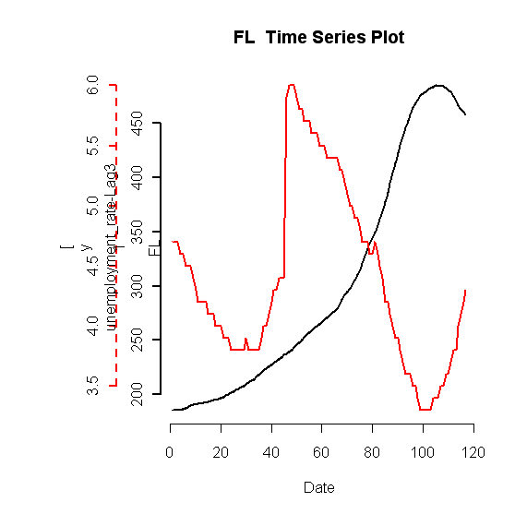
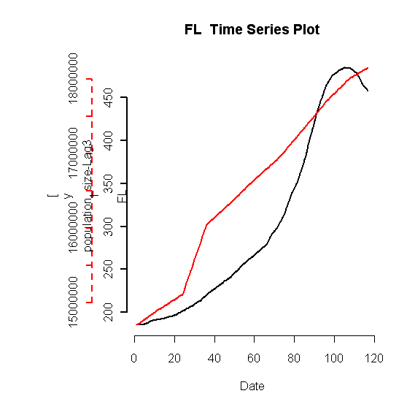
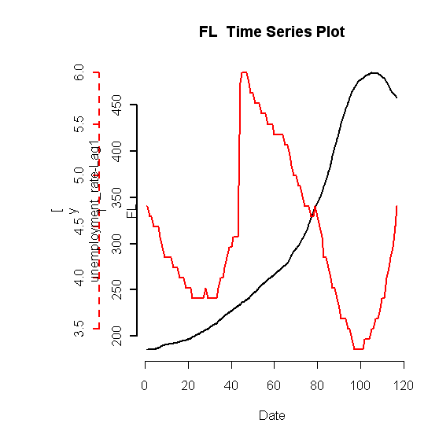
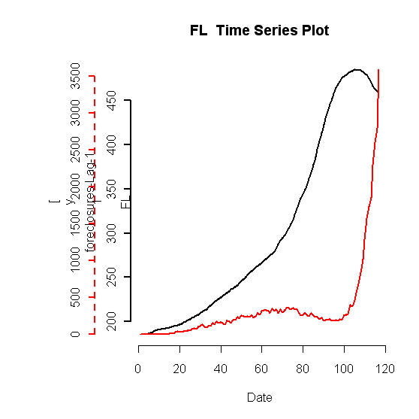
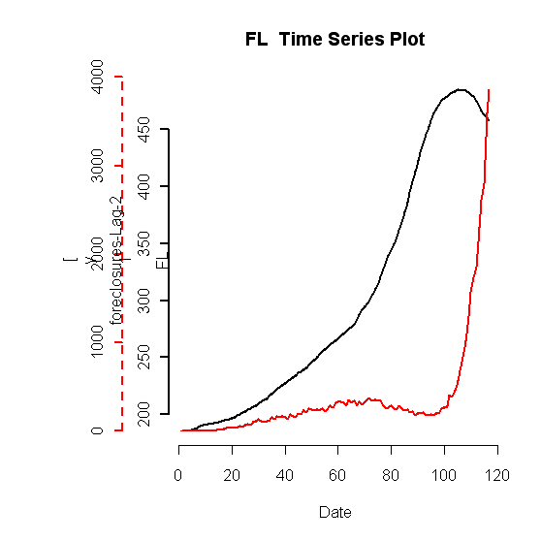
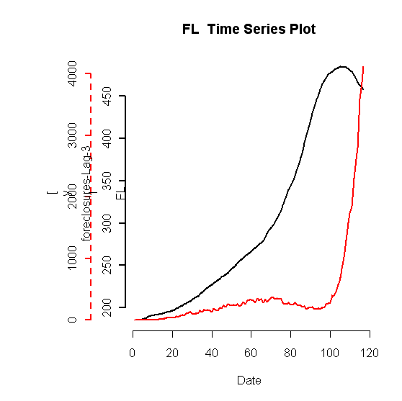
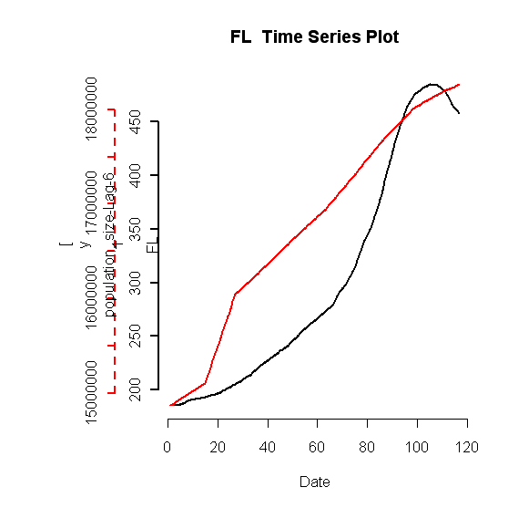
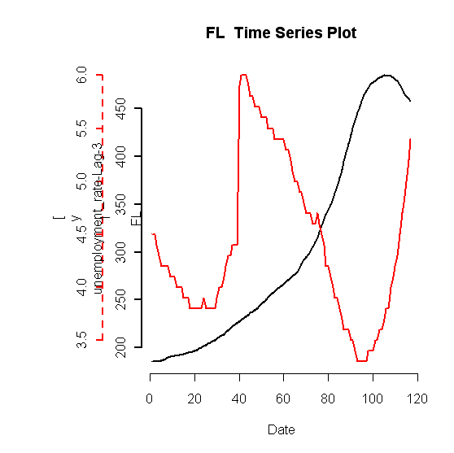
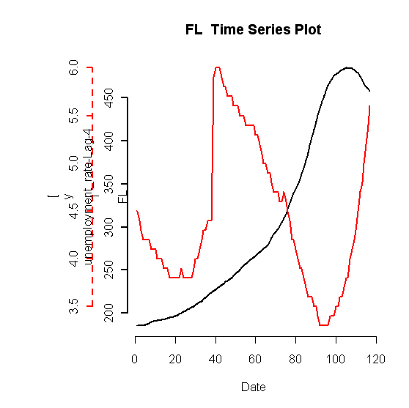

Stepwise BIC values for Regression of Lagged
Predictor Variables with Florida
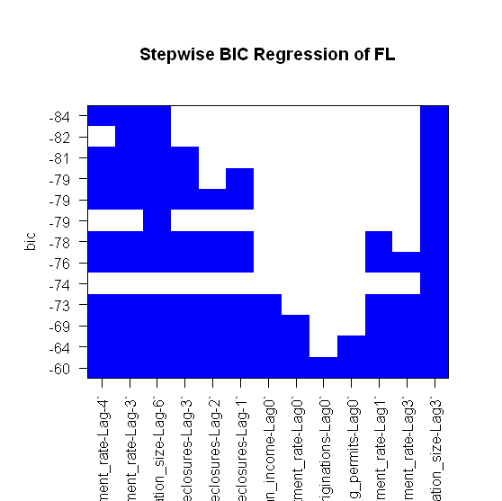

Fitted Robust Linear Model with all lagged variables
Call: rlm(x = shifted.multivar.test.data.vector[, 1:
(n - 1)], y = shifted.multivar.test.data.vector[,
n])
Residuals:
Min 1Q Median 3Q Max
-0.0159690 -0.0020288 0.0008338 0.0045595 0.0295564

Coefficients:
Value Std. Error t value
unemployment_rate-Lag-4 -0.0712 0.0162 -4.3983
unemployment_rate-Lag-3 -0.0836 0.0165 -5.0723
population_size-Lag-6 1.3061 0.4229 3.0884
foreclosures-Lag-3 -0.0026 0.0016 -1.6460
foreclosures-Lag-2 -0.0026 0.0015 -1.6699
foreclosures-Lag-1 -0.0026 0.0015 -1.7549
median_income-Lag0 -0.2167 0.2059 -1.0522
thirty_year_commitment_rate-Lag0 0.0009 0.0024 0.3597
mortgage_originations-Lag0 -0.0002 0.0010 -0.2033
building_permits-Lag0 0.0017 0.0045 0.3742
unemployment_rate-Lag1 -0.0285 0.0176 -1.6213
unemployment_rate-Lag3 -0.0237 0.0160 -1.4781
population_size-Lag3 2.9363 0.4187 7.0134

Residual standard error: 0.005344 on 103 degrees of freedom

Fitted Robust Linear Model with unlagged variables
Call: rlm(x = test.data.vector[, 1:(length(test.data.vector) - 1)],
y = test.data.vector[, length(test.data.vector)])
Residuals:
Min 1Q Median 3Q Max
-0.013701 -0.002252 0.001575 0.006133 0.047483

Coefficients:
Value Std. Error t value
median_income 0.2237 0.1666 1.3423
thirty_year_commitment_rate 0.0002 0.0030 0.0686
mortgage_originations 0.0002 0.0011 0.2014
unemployment_rate -0.1259 0.0219 -5.7532
population_size 2.9903 0.3543 8.4397
foreclosures -0.0009 0.0017 -0.5132
building_permits 0.0040 0.0051 0.7731

Residual standard error: 0.007476 on 118 degrees of freedom

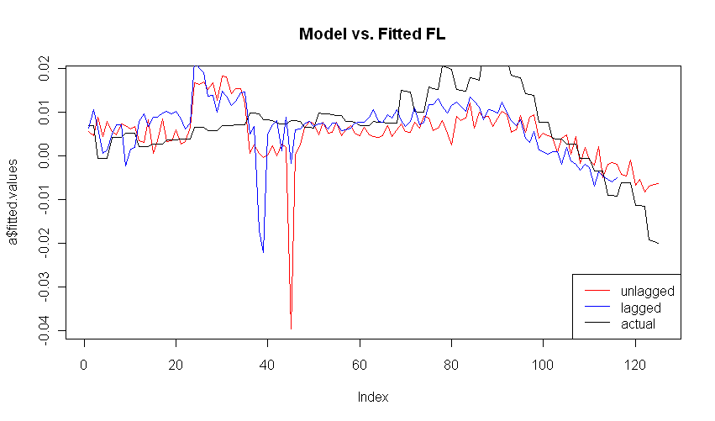
Lagged Regression Residuals Analysis:
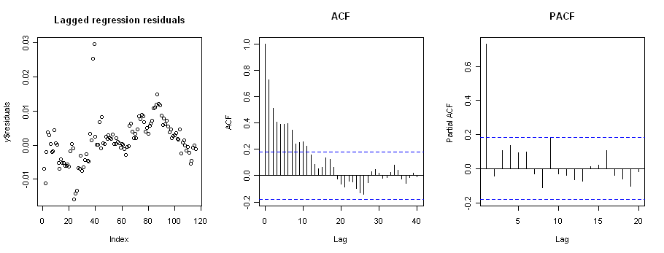
Unlagged Regression Residuals Analysis:

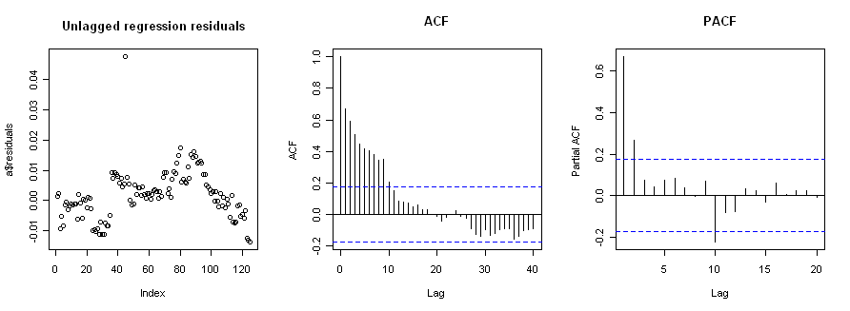

The PACF shows a lag of 2 to use in the ADF test for stationarity.
Augmented Dickey-Fuller Test

data: y$residuals
Dickey-Fuller = -3.5887, Lag order = 2,
p-value = 0.03735
alternative hypothesis: stationary

Residuals are stationary so phase 1 complete. Continue to Phase 2.

First, check Box-Ljung.
Box-Ljung test

data: y$residuals
X-squared = 220.422, df = 12, p-value < 2.2e-16

Box-Ljung fails. Implies residuals are autocorrelated. So we will now model the residuals as time series.
EACF shows that we should try to fit ARMA(1,0).

Fit ARMA:
Series: y$residuals
ARIMA(1,0,0) with non-zero mean

Call: arima(x = y$residuals, order = c(1, 0, 0))

Coefficients:
ar1 intercept
0.7356 0.0011
s.e. 0.0624 0.0015

sigma^2 estimated as 1.921e-05: log likelihood = 464.91
AIC = -923.82 AICc = -923.61 BIC = -915.56

Check adequacy of ARMA
> Box.Ljung.test(arima.fit$residuals,lag = 12, adj.DF = 12-params)

Box-Ljung test

data: data
X-squared = 12.6459, df = 11, p-value = 0.3171

The mean equation passes.

> Box.Ljung.test(arima.fit$residuals^2,lag = 12, adj.DF = 12)

Box-Ljung test

data: data
X-squared = 24.6408, df = 12, p-value = 0.01662

Residuals^2 fails. GARCH modeling needed.

FIT GARCH: Garch estimates
mu ar1 omega alpha1 beta1
4.111261e-04 3.241833e-01 3.089253e-06 1.000000e+00 2.568742e-01

Check adequacy of GARCH model (using standardized residuals)
> sresi=garch.fit@residuals/garch.fit@sigma.t
> Box.Ljung.test(sresi, lag = 12, adj.DF = 12-meanParams)

Box-Ljung test

data: data
X-squared = 10.337, df = 11, p-value = 0.5004

> Box.Ljung.test(sresi^2, lag = 12, adj.DF = 12-volParams )

Box-Ljung test

data: data
X-squared = 5.7986, df = 10, p-value = 0.8319

Both Box-Ljung tests for the standardized residuals and squared standardized residuals of the ARMA(1,0) + GARCH(1,1) model pass.

The final fitted models are as follows.

Phase 1 Regression: Drift Modeling

y_{t}=Σβ_{i}x_{t,i} + res_{t,}
where res_{t} are the residuals

Variable | β_{i,}
unemployment_rate-Lag-4 | -0.0712
unemployment_rate-Lag-3 | -0.0836
population_size-Lag-6 | 1.3061
foreclosures-Lag-3 | -0.0026
foreclosures-Lag-2 | -0.0026
foreclosures-Lag-1 | -0.0026
median_income-Lag0 | -0.2167
thirty_year_commitment_rate-Lag0 | 0.0009
mortgage_originations-Lag0 | -0.0002
building_permits-Lag0 | 0.0017
unemployment_rate-Lag1 | -0.0285
unemployment_rate-Lag3 | -0.0237
population_size-Lag3 | 2.9363

Phase 2 Time Series: Volatility Modeling

(1-φ₁B)res_{t} = φ₀ + a_{t}

σ_{t}² =αa_{t-1}² + βσ_{t-1}²
a_{t} = ε_{t}σ_{t}
ε_{t}~N(0,1)

Coefficient | Estimate
φ₀ | 0.0011
φ₁ | 0.7356
α | 1.00
β | 0.26

